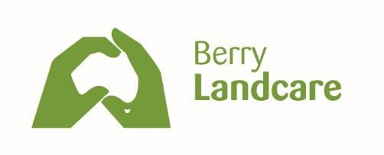 | Welcome to this walk through one of our sites

A WALK IN MOEYAN HILL RESERVE:

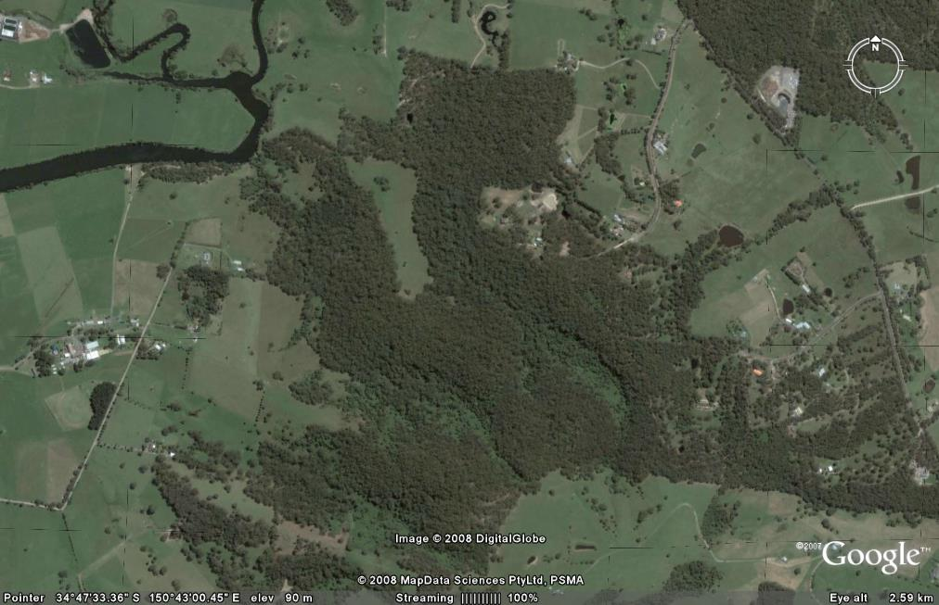

- 36 ha set aside by developers of the Berry Downs subdivision in 1974.
- Landscape value: .
  - Scenic protection zones
  - Ecologically Sensitive Zones (including EEC, Illawarra Subtropical Rainforest)
  - Adjacent heritage areas
- Corridor value Identified as part of the corridor from escarpment along Broughton Creek to Coomonderry Swamp and 7 Mile Beach National Park: Berry Landcare Corridor Project: Bushlinks Grant Dec 2015: $500,000 over 10 years
- Moeyan Hill Bushcare: a site of Berry Landcare Inc
  - Supported by Shoalhaven City Council Bushcare Programme
- Cultural Significance: Aboriginal Sites.
  - Within the Reserve, a rock shelter with evidence of habitation and two sets of sharpening grooves
  - Beyond the boundaries of the reserve, on the Western side, nearer the top of the hill, a Bunan (initiation) site, described by R H Matthews in The American Anthropologist: Vol. IX October, 1896.

Moeyan Hill forest communities described in the Remnant Vegetation Management Plan

Complex Subtropical Rainforest (COM-SRF): steep gullies on the north-western and northern slopes
- Lillypilly Acmena smithii,
- Sassafras Doryphora sassafras,
- Sandpaper fig Ficus coronata,
- Giant Stinging Tree Dendrocnide excelsa and
- Cabbage Palm Livistona australis. The floor of the rainforest has many species of fems such as
- Giant Maidenhair Fern Adiantum formosum,
- Gristle Fern Blechnum cartilagineum
- Rainbow Fern Culcita dubia,
- Sickle Fern Pellaea falcata and
- Elkhorn Platycerium bifurcatum.

Blue Gum - Blackbutt Tall Forest (SAL-PIL) Tall Forest on the northern slopes
- Blue Gum - Eucalyptus saligna/
- Eucalyptus botryoides and
- Blackbutt Eucalyptus pilularis especially along the middle to lower slopes of the gullies. It is at least 25 metres in height with a well developed deep canopy.
The understorey contains some shrub species such as
- Two-veined Hickory Acacia binervata and
- Black Wattle Acacia -mearnsii

Blackbutt - Turpentine Forest (PIL-SYN) On the ridge tops of the northern slopes:
- Blackbutt: Eucalyptus pilularis
- Turpentine: Syncarpia glomulifera.
Other tree species include
- Rough-barked Apple: Angophora floribunda,
- Grey Gum: Eucalyptus punctata
- Ironbark: Eucalyptus paniculata on the drier areas.
- Acacia binervata,
- Acacia mearnsii,
- Persoonia linearis and
- Indigofera australis.

Red Gum - Angophora Forest (TER-ANG) : In part of the northwest there are small patches
- Red Gum Eucalyptus tereticornis and
- Angophora Angophora floribunda.

Spotted Gum - Blackbutt Forest (MAC-PIL) : On the south western slopes
- Spotted Gum - Eucalyptus maculata and
- Blackbut Eucalyptus pilularis.
- Grey Ironbark Eucalyptus paniculata and
- Grey Gum Eucalyptus punctata

Turpentine Forest (SYN-FOR)
- Turpentine Syncarpia glomulifera
- Acmena smithii
- Pittosporum undulatum.

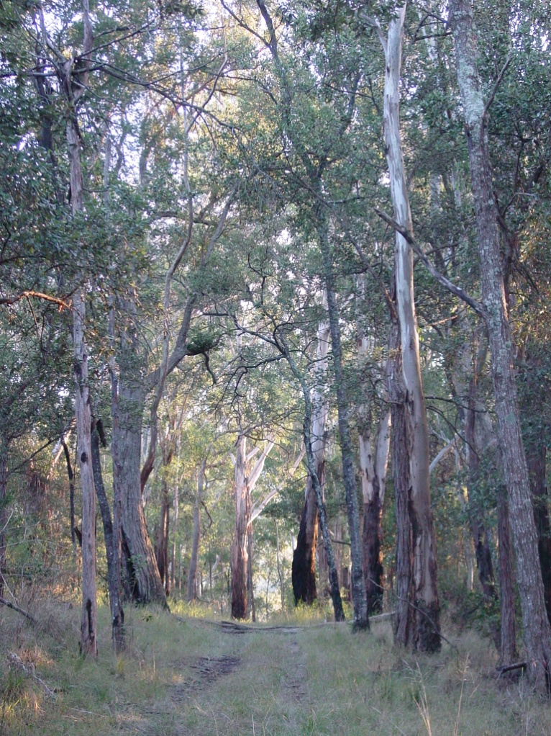 | 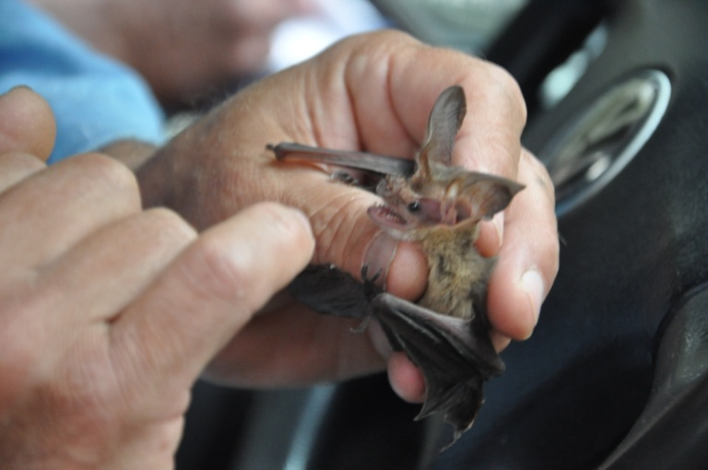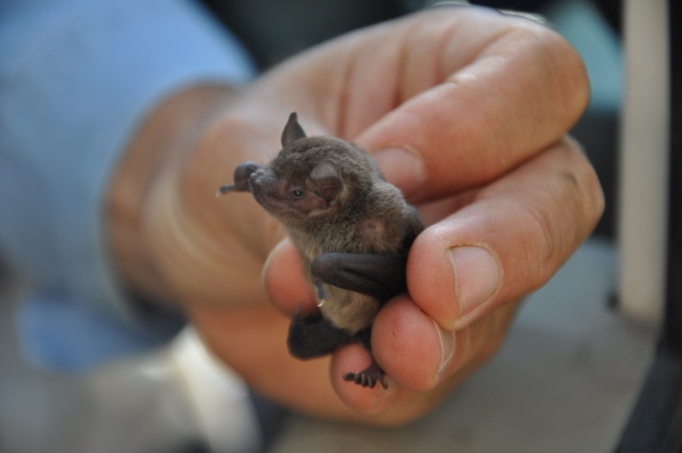
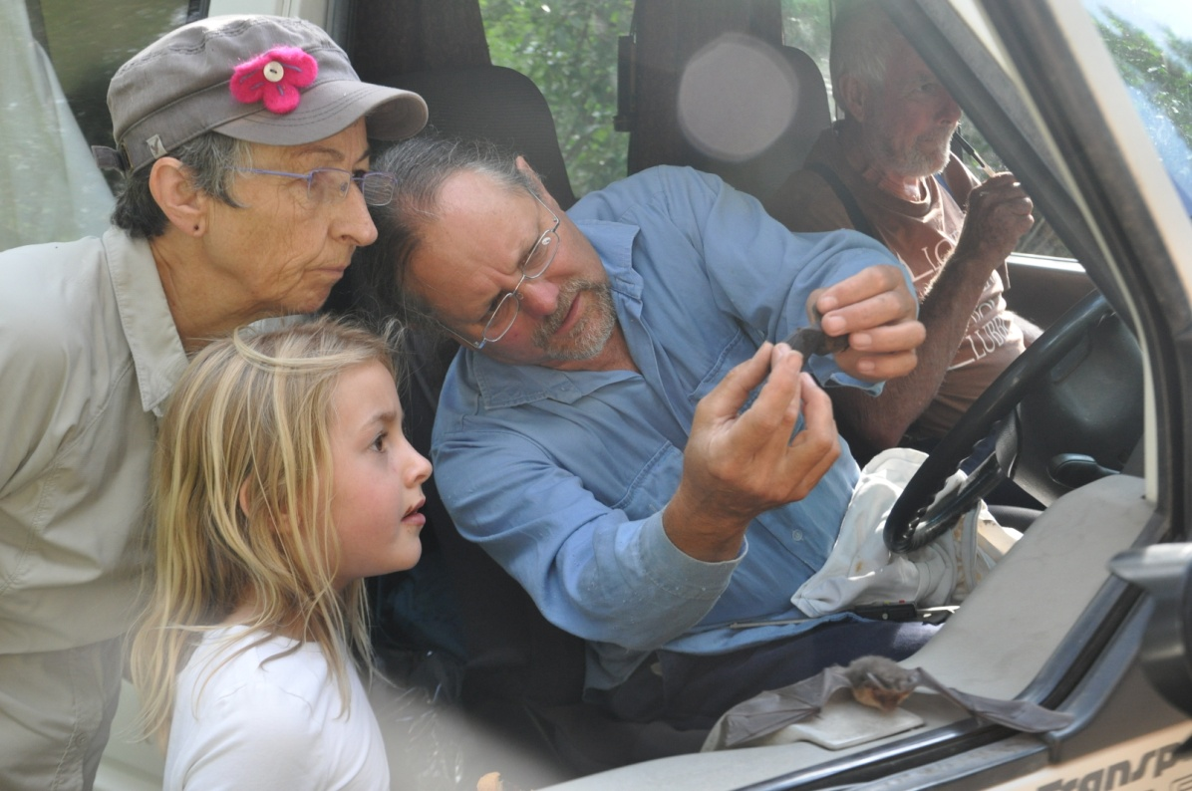

One night in January 2014, using a “harp trap”, 88 of these micro bats were caught, identified, weighed and released, along the trail we will have walked.

Moeyan Hill is within a wildlife corridor from the escarpment to the sea, which is identified in the South Coast Regional Conservation Plan and the Southern Rivers Catchment Action Plan, is reflected in the South Coast Regional Strategy, and links with the Great Eastern Ranges Corridor. Realising this corridor is a project of Berry Landcare and recognises the landscape of the Berry Area, which is heritage listed
Trees that can be found on Moeyan Hill (ones we should see on the walk)

Acacia binervata | Two-veined Hickory
Acacia maidenii | Maidens wattle
Acacia mearnsii | Black Wattle
Acmena smithii, | Lillypilly
Alectryon subcerinus | native quince
Alphitonia excelsa | Red Ash
Angophora floribunda, | Rough-barked Apple
Backhousia myrtifolia | grey myrtle
Baloghia lucida | Brush Bloodwood
Brachychiton acerifolium | Flame Tree
Callistemon saligna | willow bottlebrush
Cassine australis | Red-fruited Olive Plum
Casuarina glauca | Swamp Oak
Cerapetalum apelatum | Coachwood
Citriobatus pauciflorus | Orange Thorn
Claoxylon australe | Brittlewood
Clerodendrum tomentosum | Hairy Clerodendrum
Cryptocaria glaucescens | Jackwood-Native Laurel
Cryptocaria microneura | Murrogun
Dendrocnide excelsa | Giant Stinging Tree
Diospyros australe | Black plum
Diospyros pentamera | Gray persimmon
Diploglottis australis | Native Tamarind
Doryphora sassafras, | Sassafras
Ehretia acuminate | Koda
Elaeocarpus kirtonii | White quandong
Eucalyptus botryoides | Bangalay
Eucalyptus maculata | Spotted Gum
Eucalyptus paniculata | Grey Ironbark
Eucalyptus pilularis. | Blackbutt
Eucalyptus punctata. | Grey Gum
Eucalyptus Macrofolia | Cabbage Gum
Eucalyptus saligna | Blue gum
Eucalyptus tereticornis | Red Gum
Eupotamia laurina | Bolwarra
Exocarpus cupressiformis | Cherry Ballart
Ficus coronata | Sandpaper fig
Glochidion ferdinandi | Cheesetree
Indigofera australis.
Livistona australis. | Cabbage Palm
Melaleuca styphelioides | Prickly-leaved Tea-tree
Melalueca quinquenerva | Broad-leafed paperbark
Melia azerdarach | White Cedar
Melicope micrococca | White Melicope
Notalea venosa | Native 0live
Notelea longifolia | Native olive
Omalanthus populifolius | Bleeding Heart
Persoonia linearis | Narrow-leaved Geebung
Pittosporum revolutum | Rough Fruiting pittosporum
Pittosporum undulatum. | Sweet pittosporum
Polyscias murrayi | Pencil Cedar
Rapanea variabilis | Mutton wood
Rhodamnia rubescens | Scrub Turpentine
Stenocarpus saligna | scrub beefwood
Streblus brunonianus | Whalebone Tree
Syncarpia glomulifera | Turpentine
Synoum glandulosum | Bastard Rosewood
Syzigium australe | Brush Cherry
Toona ciliata/australis | Red Cedar
Trema aspera | Native Peach
Wilkiea huegeliana | Common Wilkiea

Ferns:
Giant Maidenhair Fern Adiantumformosum
Gristle Fern Blechnum cartilagineum
Rainbow Fern Culcita dubia,
Sickle Fern Pellaea falcata
Elkhorn Platycerium bifurcatum

References:
- Remnant Vegetation, Management Plan, Moeyan Hill, Shoalhaven City Council, November 1998 by Julian Laing and Peter Dalmazzo;
- Berry Bushcare site visits, Alasdair Stratton (SCC), David Curtis (SR-CMA)

